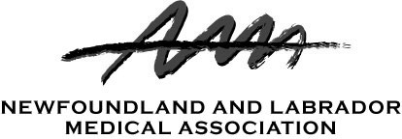

PROXY

This proxy is being solicited from members who are unable to attend the Annual General Meeting.

The undersigned hereby appoints (check one box indicating your selected Proxyholder):
□ Dr. Cynthia Slade, President NLMA

OR
□ _______________________________________________________ (Name of Proxyholder)

as proxy for the undersigned to attend, act and vote for and on behalf of the undersigned at the annual meeting of the Newfoundland and Labrador Medical Association to be held in St. John’s on June 6, 2026 and at any adjournment or adjournments thereof in the same manner to the extent and with the same power as if the undersigned were present at the said meeting, or such adjournment or adjournments thereof.

Dated at_______________________________this______day of____________________2026

Signature_____________________________Print Name______________________________

In order to be valid, this proxy must be received no later than the commencement of the meeting in respect of which the proxy was granted.

Please submit forms to: legal@nlma.nl.ca

Only voting members (practicing, retired and resident members) are eligible to vote

